Enhanced Ransomware Classification Using PSO-Based Feature Weighting and Multi-Classifier Ensembles

Meet Mandalia
Department of Computer Engineering. Marwadi University
Marwadi University,Rajkot,Gujarat,India
Rajkot, India
meetmandalia008@gmail.com
ABSTRACT
Ransomware attack has been quite a widespread cybersecurity threat that has led to a massive loss of money and business disruption. The existing signature-based and heuistic-based methods of detection cannot make the final stand against ever-developing ransomeware variants. Machine learning (ML)-based systems depict word but the size of feature spaces is also a significant challenge. This paper outlines an innovative strategy involving a combination of ensemble classifiers and feature selection through Particle Swarm Optimization (PSO) method. Two ensemble models are created: with Random Forest (RF) and Support Vector Machine (SVM) and with Decision Tree (DT) and K-Nearest Neighbours (KNN). PSO is used to determine the best feature subsets and weigh them. Experiments with a custom dataset containing 175 ransomware executables of 28 families and 45 benign samples show that PSO-aided feature selection yields a high detection accuracy, precision, recall, and F1-score. The most accurate model is the DT+KNN, PSO ensemble with the highest accuracy of 98.38 and better than the single classifier and unweighted ensemble models. Findings support the suitability of adopting metaheuristic feature selection coupled with ensemble learning in detecting ransomware.
Keywords: Ransomware; Machine Learning; Ensemble Classifiers; Feature Selection; Particle Swarm Optimization

I. INTRODUCTION
Ransomware is a virus, which codes up the data of a victim and requires money to be decrypted. It has matured out of rudimentary programs, floppy-distributed, in the late 1980s, like the so-called AIDs/PC Cyborg trojan, to highly automated, goal-oriented methods of attack by leveraging the anonymity of cryptocurrency and via Ransomware-as-a-Service (RaaS) providers. The causes of high-profile ransomware strikes like WannaCry (2017), NotPetya (2017), and the attack on the Colonial Pipeline (2021) have proven the disastrous financial and operational impact of large-scale ransomware. Non-icb models like signature-based and heuristic-based traditional methods of detection cannot fight new and obfuscated ransomware. They only identify known variants, vulnerable to zero-day attacks, and have high false positive and negative rates. The new approach of ML-based techniques has proven to be a prospect, but due to the high dimensionality of feature spaces, scarce training data, and the ever-changing characteristics of ransomonware, the detection accuracy remains a challenge. The proposed research tackles these issues by combining PSObased feature selection and ensemble classification. The objectives are: (1) to compare PSO with critical selection of features of ransomware (static and dynamic), and (2) comparing ensemble models (RF-SVM and DT-KNN) in terms of their accuracy, precision, recall and F1-score. A set of 289 custom data set is made. ransomware families,

and samples can be run in a sandbox (DRAVUF) to extract both a static (PE-based) and dynamic (API call) features.
II. LITERATURE REVIEW
The ransomware detection research has been characterized as traditional, ML-based, network-based, and hybrids. The classic signature-based and heuristic approaches are well-recognized to be only effective on known variants and extremely vulnerable to obfuscation and zero-day attacks [1], [2], [3] were the first to apply the ML-based techniques to the specific case of ML: they used Principal Component Analysis (PCA) to reduce the dimensions of the stationary PE data and stacked ensemble classifiers.[4], a dynamic analysis system based on N-gram features and TF-IDF to select the features. [5] created DPBD-FE, dynamically defining the pre-encryption stage and extracting features using an annotated TF-IDF, where Random Forest works well at all times. [6] suggested a hybrid dominant feature selection method based on correlation coefficient and mutual information to analyze ransomware in Android. Aurangzeb et al. [7] introduced the concept of BigRC-EML, a hybrid of big-data and ensemble ML, and PCA to classify ransomware. There has also been an exploration of deep learning methods came up with IMCEC, which is a combination of posterior probabilities of several CNN architectures. In an ensemble,suggested MalNet, which is a combination of CNN-based images features with LSTM-based opcode analysis. Yet, CNN visual methods fall short in terms of sensitivity to opcode variations and fixed input-size. Abbasi et al. used PSO-based features selection and proposed a wrapper algorithm (Regularized Logistic Regression) and compared various PS variants with different classifiers (RF, DT, SVM, KNN) and concluded that there was no single best-performing classifier based on selection. demonstrated RF to be better at RF than AdaBoost, Bagging, and Rotation Forest. affirmed that RF is an effective classifier, better than DT, NB, LR and NN classifiers. SVM based classifiers to reduce adversarial evasion of ransomware.show that network-based detection is viable in classifying traffic-based ransomware, but usually only against narrow groups of ransomware. The current paper expands this literature by combining PSO-selected features with ensemble classification using a custom dataset of 28 ransomware families.
III. METHODOLOGY
Malware Bazaar was used as the source of ransomware samples. The 1,000 most recent samples, separated by family, and without families having any less than 5 samples were extracted in a Python script. The the ransomware dataset includes 175 executables that belong to 28 different families (Table I). Another 45 benign train / 5 test Windows PE samples were used (40 train / 5 test). The samples were all run in a DRAKVUF-based sandbox (Ubuntu 20.04 LTS host, Windows 10 guest, 2-core CPU, 4 GB RAM) with Virtual Machine Introspection (VMI) enabled to ensure that each sample did not run sandbox-evasion behaviors, and each different sample was monitored during 1 minute.TABLE I. Distribution of the Ransomware Families and Samples
TABLE I. Ransomware Families and Sample Distribution
Ransomware Family | Samples
Azov | 5
Babuk | 5
Blackbasta | 10
Blackcat | 5
Blackcocaine | 5
Blackmatter | 5
Chaos | 10
Conti | 5
Cyborg | 5
Dharma | 10
Gandcrab | 5
GlobeImposter | 5
Hiddentear | 5
Hive | 5
Medusalocker | 5
Neshta | 5
Nitro | 5
Njrat | 5
Phobos | 5
Ransomware | 5
RedlineStealer | 5
Seven | 5
Stop | 5
Thanos | 5
WannaCry | 10
Xorist | 10
Lockbit | 10
Makop | 10

B. Feature Development and Engineering.
The PE Parser Python library was used to extract feature of the code (metadata, frequency of symbols, frequency of 1-gram opcode, number of times referenced by registry, 1-data-define directives, PE section attributes, random assorted attribute) 105 features in total. DRAKVUF was used to capture dynamic features -260 API call counts. Table II condenses all categories of features.
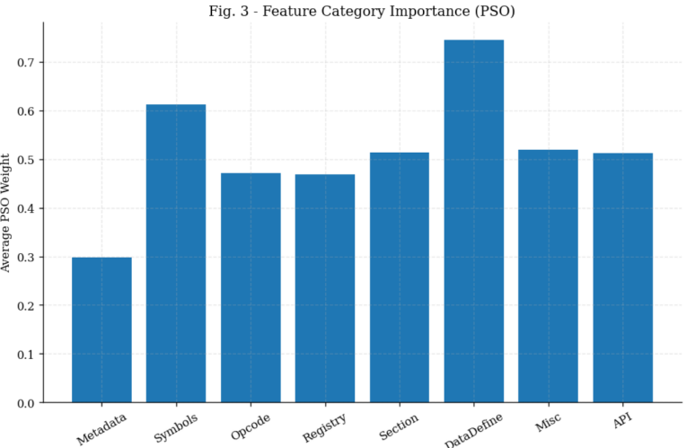
Fig.1 Feature Categories

TABLE II. Category Counts and Categories of features.
Feature Category | No. of Features
Metadata | 2
Symbols Frequency | 7
1-Gram Opcode | 22
Registry | 20
Section | 5
Data Define Directives | 5
Miscellaneous | 44
Dynamic API Calls | 260
Total (Static + Dynamic) | 365

C. Model Implementation
PSO was used through the PySwarms library (social parameter c1 = cognitive parameter c1 = 1.25, inertia w = 0.2, swarm size (50-100) = 5, 100 epochs/run, 100 independent runs). PSO calculates a fitness value on a feature; this set of weights are bit-wise multiplied by feature values before classification. All classifiers were done with scikit-learn. The optimal hyperparameters were optimized through a grid search: RF (n_estimators = 30, max_features = sqrt, min_samples_leaf = 4); SVM (C = 100, gamma = 0.001, RBF kernel); DT (criterion = Gini, max_depth = 5, min_samples leaf = 5); KNN (n -neighbors RF weight 5, SVM weight 4; KNN weight 5, DT weight 4 are used in ensemble decision. Direct comparison: A baseline experiment, PSO (equal weights), was performed.
IV. RESULTS AND DISCUSSION
A. Classification Accuracy
The detection accuracy of each of the classifier configurations is shown in table III. The PSO-generated DT+KNN ensemble is the most accurate with accuracy at 98.38 and beats each of its own components (DT: 94.13; KNN: 98.36) and the unweighted PSO-generated ensemble (98.05). RF + SVM ensemble using PSO has a score of 93.82 just higher than with no PSO (93.56%). What these findings validate is that, feature weighting according to PSO can continuously increase the detection accuracy particularly with a combination of DT and KNN.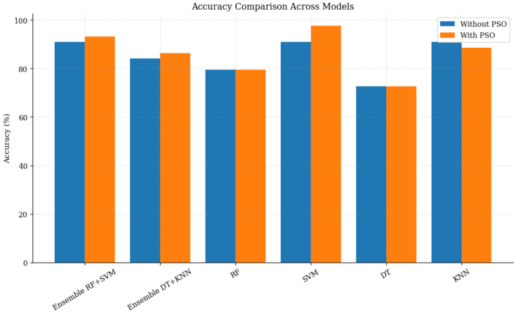
Fig.2 Accuracy Comparision
TABLE III. . Accuracy of all methods in classifying materials.
Classifier Setup | With PSO (%) | Equal-Weighted (%)
Ensemble RF+SVM | 93.82 | 93.56
Ensemble DT+KNN | 98.38 | 98.05
RF (Individual) | 93.05 | 93.00
SVM (Individual) | 89.74 | 89.74
DT (Individual) | 94.13 | 93.36
KNN (Individual) | 98.36 | 97.44

B. Precision, Recall, F1-Score - Ensemble Classifiers
Table IV shows complete assessment results of both ensemble classifiers. The maximum accuracy of 99.77% is attained with the DT+KNN ensemble whether PSO is incorporated or not. In both configurations, the RF+SVM ensemble is performing at 100% with respect to recalling all positive instances and, hence, this is its strength. As in the case of PSO, the DT+KNN ensemble with the maximum F1-score of 99.09 per which to verify the most balanced overall performance can be made. RF+SVM ensemble has the lowest ensemble F1-score of 96.54%.Fig.3 Ensemble Classifier Performance.Fig.3 Ensemble Classifier Performance.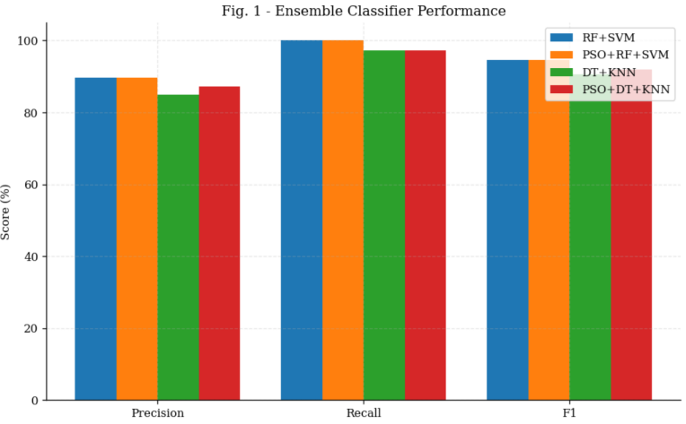
Fig.3 Ensemble Classifier Performance
TABLE IV. Precision, Recall and F1-Score - Ensemble Classifiers.
.Classifier | Condition | Precision (%) | Recall (%) | F1-Score (%)
RF+SVM | With PSO | 93.57 | 100.00 | 96.68
RF+SVM | Without PSO | 93.33 | 100.00 | 96.54
DT+KNN | With PSO | 99.77 | 98.43 | 99.09
DT+KNN | Without PSO | 99.77 | 98.06 | 98.90

C. Precision, Recall, and F1-Score — Individual Classifiers
Individual classifier metrics are shown in Table V. KNN PSO has the most precise (98.22%) and F1-score (99.10) of the individual classifiers. In both configurations, SVM achieves the lowest precision (89.74) which means it has a greater false positives. The KNN and SVM are both ideal recallers (100%), regardless of the combination with PSO. Integrating the PSO increases KNN accuracy by about 1 and DT F1-score by 0.43. 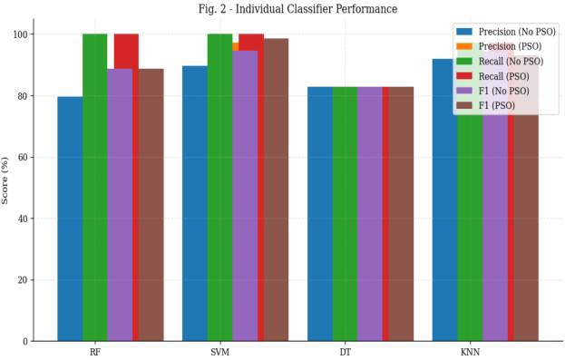
Fig.4 Individual Classifier Performance
TABLE V. Precision, Recall and F1-Score — Individual Classifiers
Classifier | Condition | Precision (%) | Recall (%) | F1-Score (%)
RF | With PSO | 97.22 | 97.97 | 96.70
RF | Without PSO | 96.48 | 97.91 | 96.19
SVM | With PSO | 89.74 | 100.00 | 96.86
SVM | Without PSO | 89.74 | 100.00 | 96.11
DT | With PSO | 96.62 | 96.86 | 94.59
DT | Without PSO | 94.49 | 96.11 | 94.59
KNN | With PSO | 98.22 | 100.00 | 99.10
KNN | Without PSO | 97.22 | 100.00 | 98.59

D. PSO Feature Importance Analysis
PSO fitness feature category values of the two ensembles models are 0.44-0.56 meaning that the categories are broadly applicable. Both RF+SVM and DT+KNN models give this category (1-Gram Opcode) the highest average weight (RF+SVM: 0.5042; DT+KNN: 0.507), highlighting the significance of instructions on the assembly level. Other categories, such as Dynamic API calls, Registry, Symbols and Metadata depict similar contributions which substantiate that both the static features and dynamic features work together in detection. Based on the Table 4, it appears that the RF+SVM and DT+KNN models have identified different features as being important for detecting ransomware. In the RF+SVM model, the features ASM 1GRAM OPCODES al and ASM 1GRA OPCODES jg are highlighted as influential. These features represent specific assembly language instructions related to addition and jump-if-greater operations, respectively. Additionally, the RF+SVM model considers features such as NtAlpcSendWaitReceivePort, NtTraceControl, NtOpenProcessToken, NtCreateFile and others as significant for detecting ransomware. On the other hand, the DT+KNN model identifies ASM 1GRAM OPCODES call and ASM 1GRAM OPCODES dw as the most influential features. These features represent assembly language instructions related to ”call” and ”Define Word” operations, respectively. The DT+KNN model also considers features like NtSetEvent, NtQueryFullAttributesFile, NtMapViewOfSectionEx, NtGetCachedSigningLevel, and others as important indicators of ransomware. In summary, the observations indicate that different combinations of features, including assembly language instructions and specific Windows API calls, are deemed important by the RF+SVM and DT+KNN models in identifying ransomware.
TABLE VI. Top 10 Features, found in each Ensemble, identified by PSO
.Rank RF | RF+SVM Ensemble Indicators | DT+KNN Ensemble Indicators
1 | ASM 1GRAM OPCODES: cry! | ASM 1GRAM OPCODES jg
2 | ASM 1GRAM OPCODES: jg | ASM 1GRAM OPCODES dw
3 | NtAlpcSendWaitReceivePort | ASM Directive:dc por
4 | NtTraceControl | NtSetEvent
5 | NtOpenProcessToken | NtCreateFile
6 | NtCreateFile | NtQueryFullAttributesFile
7 | NtUnsubscribeWnfStateChange | NtMapViewOfSectionEx
8 | NtCreateWnfStateName | NtGetCachedSigningLevel
9 | NtAcceptConnectPort | NtReadFileScatter
10 | NtQueryDefaultUILanguage | NtUnloadKeyEx

V. CONCLUSION
This paper introduced a new ransomware detection scheme that involved the use of PSO based feature selection and ensemble ML classification. Two modeling to RF + SVM and DT + KNN were tested using a non-stringent dataset of 175 ransomware and 28 families and 45 healthy samples, including 365 constant and dynamic features. Findings affirm that the feature weighting based on PSO gives a constant improvement in detection accuracy when compared to equal-weighting baselines. The grades of the DT+KNN+PSO ensemble are the best with its highest accuracy of 98.38, precision of 99.77, recall of 98.43, and F1-score of 99.09. RF+SVM+PSO has a recall of 100% and is thus highly applicable in the high sensitivity deployment situation where loss of ransomware is the main consideration. Further considerations in working might involve consideration of alternative metaheuristic algorithms (e.g., the Genetic Algorithms, the Ant Colony Optimization), the integration of ensemble models with deep learning elements, the Bayesian hyperparameter optimization, and testing with larger, more varied data sets to determine generalizability to ransomware families and deployment settings.
REFERENCES
- Neel Kumar Yadav Gurukala, Deepak Kumar Verma. Feature Selection using Particle Swarm Optimization and Ensemble-based Machine Learning Models for Ransomware Detection, 15 November 2023, PREPRINT (Version 1) available at Research Square [https://doi.org/10.21203/rs.3.rs-3604834/v1].
- Sumaiah Algarni. “Cybersecurity Attacks: Analysis of “WannaCry” Attack and Proposing Methods for Reducing or Preventing Such Attacks in Future”. In: ICT Systems and Sustainability (2021). Ed. by Milan Tuba, Shyam Akashe, and Amit Joshi, pp. 763–770.
doi: http://dx.doi.org/10.1007/978-981-15-8289-9_73.
- Collin Eaton and Dustin Volz. “Colonial Pipeline CEO tells why he paid hackers a 4.4 million ransom”. In: The Wall Street Journal (2021). url: https://www.wsj.com/articles/colonialpipeline- ceo-tells-why-he-paid-hackersa- 4-4-million-ransom-11621435636
- Tsvetan Tsvetanov and Srishti Slaria. “The effect ofthe Colonial Pipeline shutdown on gasoline prices”.In: Economics Letters 209 (2021), p. 110122. issn:0165-1765. doi: https : / / doi . org / 10 . 1016 / j.econlet.2021.110122. url: https://www.sciencedirect . com / science / article / pii /S0165176521003992.
- Nahush Shetty and Raja Praveen. “A survey paperon malware detection techniques”. In: International Journal 10 (2 2021). doi: https://doi.org/10.30534 / ijatcse / 2021 / 151022021. url: http ://www.warse.org/IJATCSE/static/pdf/file/ijatcse151022021.pdf.
- Md Jobair Hossain Faruk et al. “Malware Detection and Prevention using Artificial Intelligence Techniques”. In: 2021 IEEE International Conference on Big Data (Big Data). 2021,pp. 5369–5377. doi: 10.1109/BigData52589.2021.9671434.
- Abdullah Alqahtani and Frederick T. Sheldon. “A Survey of Crypto Ransomware Attack Detection Methodologies: An Evolving Outlook”. In: Sensors 2022, Vol. 22, Page 1837 22 (5 Feb. 2022), p. 1837. issn: 1424-8220. doi: 10.3390/S22051837. url: https : / / www . mdpi . com / 1424 - 8220/22/5/1837.

